Fundamental of Programing

Lab Manual # 04

**Course Instructor:** Dr Jawad Khan

**Lab Instructor:** Muhammad Affan

## Student Name:

## Muhammad Ali Shahzadah

## CMS ID:

## 466353

**Lab Manual # 04**

**Loops (Part-01)**

# Lab Task:

1. Write a program in C++ to find the sum of first 10 natural numbers.

#include <iostream>

using namespace std;

int main(){

int sum, x;

for(int i=1;i<=10;i++){

cout<<"enter a number to add: ";

cin>>x;

sum=sum+x;

}

cout<<"sum of the first 10 natural numbers is: "<<sum<<endl;

}

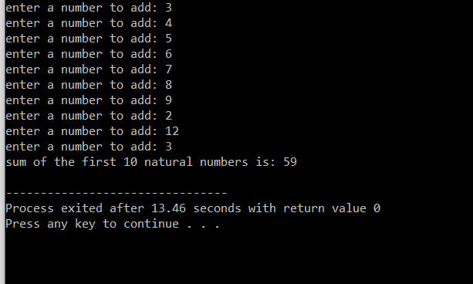

1. Write a C++ program to Print a Table of any Number.

The output should look like this:

#include <iostream>

using namespace std;

int main(){

int num;

cout<<"Enter a number fro whcih table is needed: ";

cin>>num;

for(int i=1;i<=10;i++){

cout<<num<<" x "<<i<<" = "<<num*i<<endl;

}

}

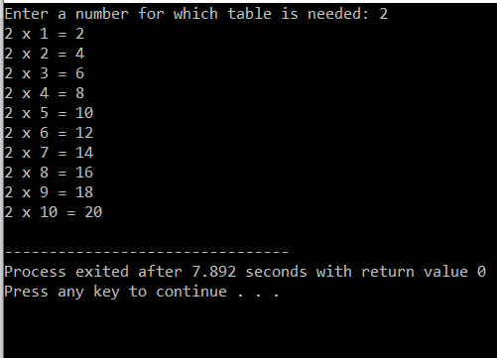

1. Write a Program to Generate Factorial. A Certain Number Factorial of any number is the product of an integer and all the integers below it for example factorial of 4 is: 4! = 4 * 3 * 2 * 1 = 24

#include <iostream>

using namespace std;

int main() {

int num;

int fact=1;

cout<<"enter number to find factorial of: ";

cin>>num;

int x=num;

for(int i=0;i<=x-1;i++){

fact=fact*(num);

num=num-1;

}

cout<<"factorial of number "<<x<<" is: "<<fact<<endl;

}

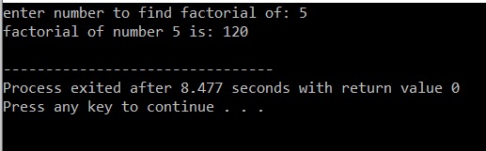

1. Write a C++ program to generate a Fibonacci sequence up to a certain number input by the user.

#include <iostream>

using namespace std;

int main() {

int n;

int a,b,c;

cout<<"enter the first num: ";

cin>>a;

cout<<"enter the second num: ";

cin>>b;

cout<<"enter how many values to output: ";

cin>>n;

for(int i=0;i<n;i++){

cout<<a<<" ";

c=a+b;

a=b;

b=c;

}

cout<<endl;

}

